CONTEXT LEVEL DFD:

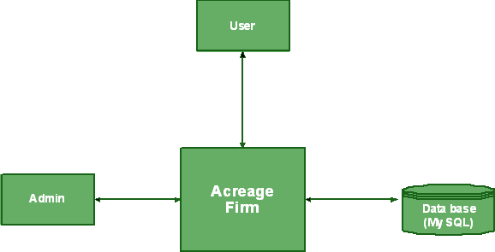
Back

Forty

Dense

LEVEL 0 DFD FOR ADMIN:

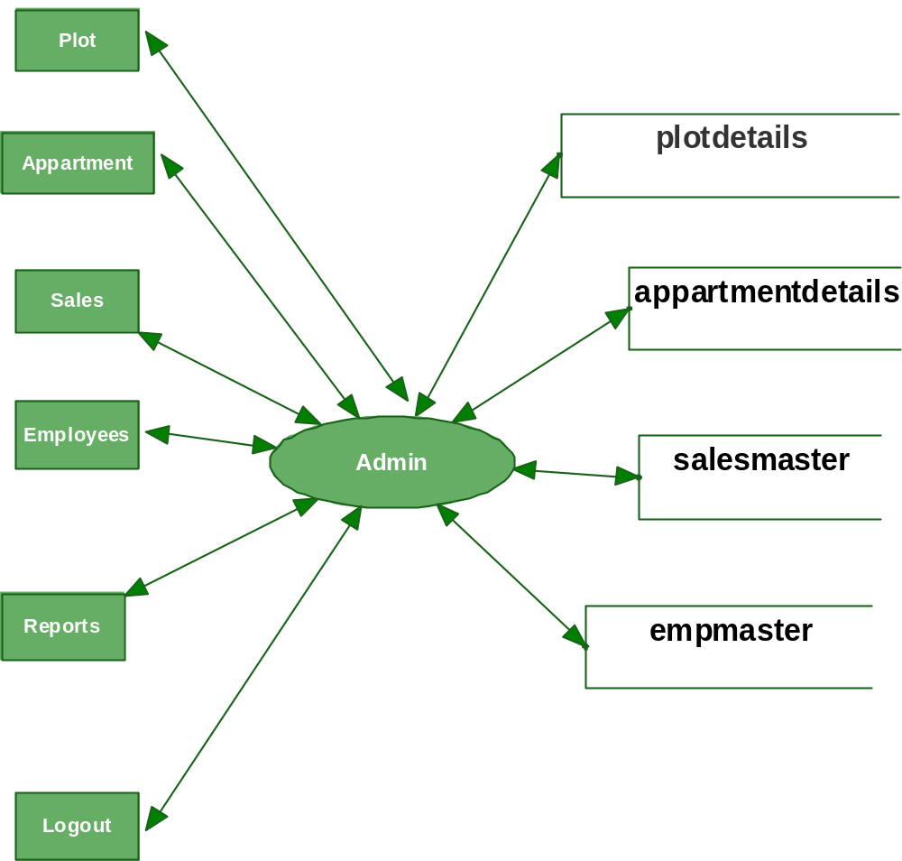

LEVEL 0 DFD FOR USER:

